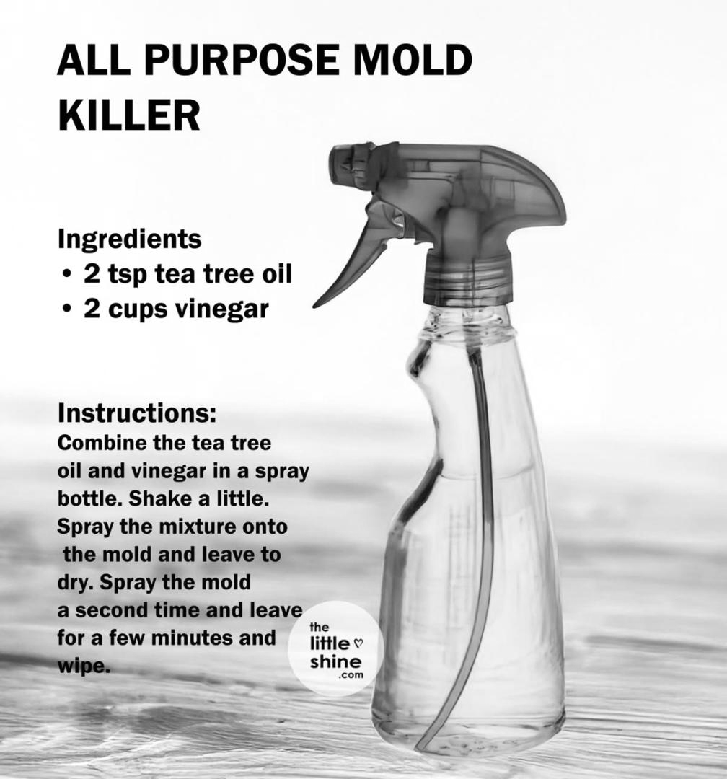
Tea Tree Oil is an essential oil, Its antibacterial and anti-fungal properties also make it the ideal cleaning agent as it will kill off germs!

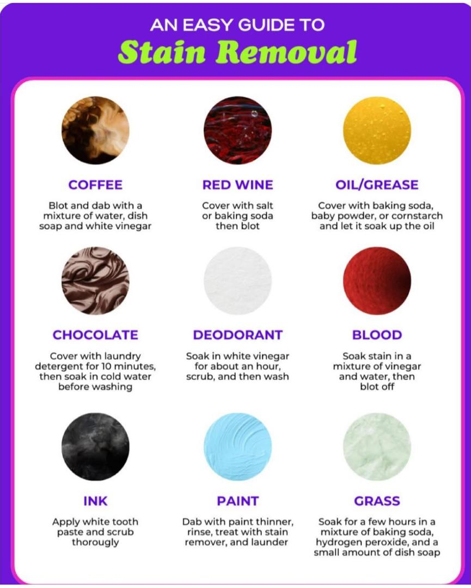
Try these laundry hacks and enjoy stain-free laundry days!

